The Bavaria C50

EUR 420,000

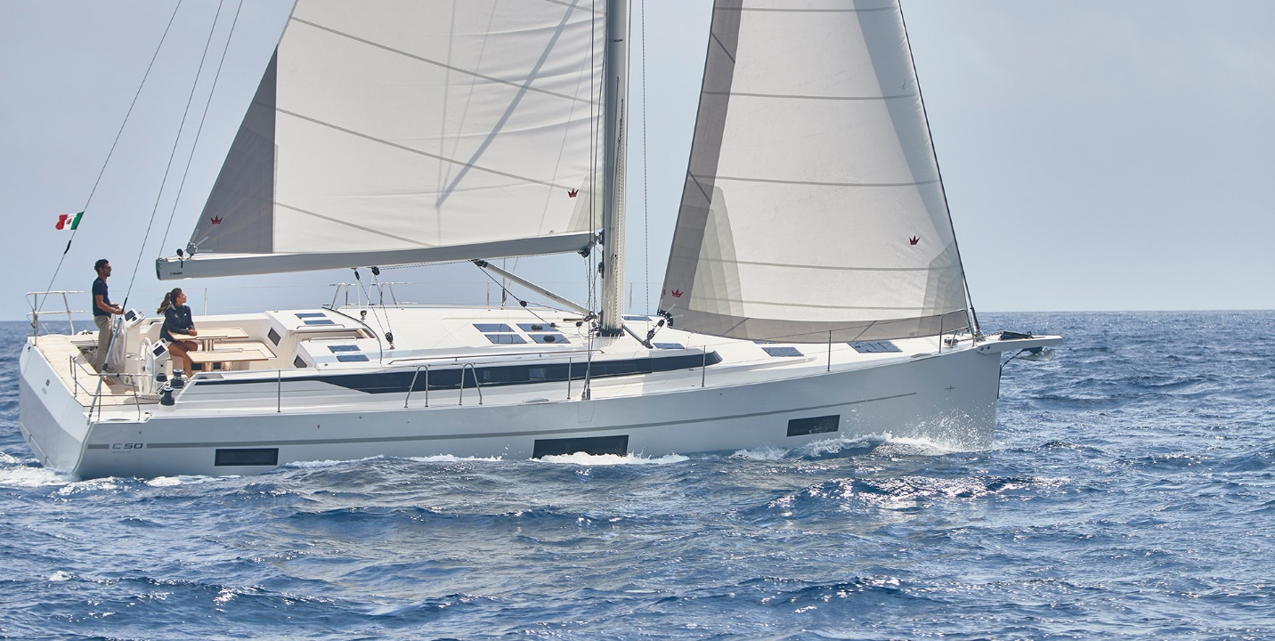

## Asking price: **EUR 420,000**

## Built: **2019, Grimes, Alexandria**

## Length: **59.2m (290.6ft)**

## Cabins: **4**

## Berths: **5**

# Description:

# Beauty and performance.

### With family or with friends – the BAVARIA C50 is about the pleasure of sailing, but it’s about relaxation too. Together you can enjoy a fabulous time on water or on land, and with a lot of people. That’s because, as well as a three, four and five‐cabin version there is even a six‐cabin version available. As with the BAVARIA C45, the C50 comes in two different equipment levels: ’Holiday’ and ’Style’.